Assignment 2 SECPH 2523

QUESTION 1
Table 2.1 STUDENTFINE records data on traffic offences by students in acollege.
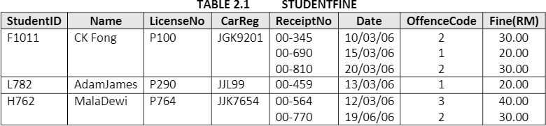
- Table 2.1 is said to be unnormalized table. Why?
- Transform the unnormalized Table 2.1 into a First Normal Form (1NF) table. Show the transformed 1 NF table. What is the primary key for this new 1 NF table.

a) Because there are multi-valued attributes in a single column.
b)
StudentID (PK) | Name | LicenseNo | CarReg | ReceiptNo | Date | OffenceCode | Fine(RM)
F1011 | CK Fong | P100 | JGK9201 | 00-345 | 10/03/06 | 2 | 30.00
F1011 | CK Fong | P100 | JGK9201 | 00-690 | 15/03/06 | 1 | 20.00
F1011 | CK Fong | P100 | JGK9201 | 00-810 | 20/03/06 | 2 | 30.00
L782 | AdamJames | P290 | JJL99 | 00-459 | 13/03/06 | 1 | 20.00
H762 | MalaDewi | P764 | JJK7654 | 00-564 | 12/03/06 | 3 | 40.00
H762 | MalaDewi | P764 | JJK7654 | 00-770 | 19/06/06 | 2 | 30.00
PK: StudentID

QUESTION 2
The following table is un-normalized table that is created to manage a consulting company’s operations. Create its normalized forms (1NF, 2NF, and 3NF). Note: Define the PK and FK for each table:

Project number | Project name | Employee number | Employee name | Rate category | Hourly rate
1023 | Madagascar travel site | 11 | Vincent Radebe | A | $60
 |  | 12 | Pauline James | B | $50
 |  | 16 | Charles Ramoraz | C | $40
1056 | Online estate agency | 11 | Vincent Radebe | A | $60
 |  | 17 | Monique Williams | B | $50

Ans:

1NS
Project number | Project name | Employee number | Employee name | Rate category | Hourly rate
1023 | Madagascar travel site | 11 | Vincent Radebe | A | $60
1023 | Madagascar travel site | 12 | Pauline James | B | $50
1023 | Madagascar travel site | 16 | Charles Ramoraz | C | $40
1056 | Online estate agency | 11 | Vincent Radebe | A | $60
1056 | Online estate agency | 17 | Monique Williams | B | $50

PK: Project number
FK: Employee number

2NF

Project Table
Project number | Project name
1023 | Madagascar travel site
1056 | Online estate agency

PK: Project number
FK: -

Employee Table
Employee number | Employee name | Rate category | Hourly rate
11 | Vincent Radebe | A | $60
12 | Pauline James | B | $50
16 | Charles Ramoraz | C | $40
11 | Vincent Radebe | A | $60
17 | Monique Williams | B | $50

PK: Employee number
FK: -

3NF

ProjectEmployee Table
Project number | Employee number | Rate category
1023 | 11 | A
1023 | 12 | B
1023 | 16 | C
1056 | 11 | A
1056 | 17 | B

PK: -, FK: Project number, Employee number, Rate category

Project Table
Project number | Project name
1023 | Madagascar travel site
1056 | Online estate agency

PK: Project number, FK: -

Employee Table
Employee number | Employee name
11 | Vincent Radebe
12 | Pauline James
16 | Charles Ramoraz
11 | Vincent Radebe
17 | Monique Williams

PK: Employee number, FK: -

Rate category | Hourly rate
A | $60
B | $50
C | $40

PK: Rate category, FK: -

